Number 01

January 2018

**Raising inclusion into the labour market of refugees, asylum seekers and migrants, on the base of entrepreneurial competencies development**

**“Raising inclusion into the labour market of refugees, asylum-seekers and migrants, on the base of entrepreneurial competencies development ”**

**RIECE 2017-1-LT01-KA204-035194**

**“Raising inclusion into the labour market of refugees, asylum-seekers and migrants, on the base of entrepreneurial competencies development ”**

**RIECE 2017-1-LT01-KA204-035194**

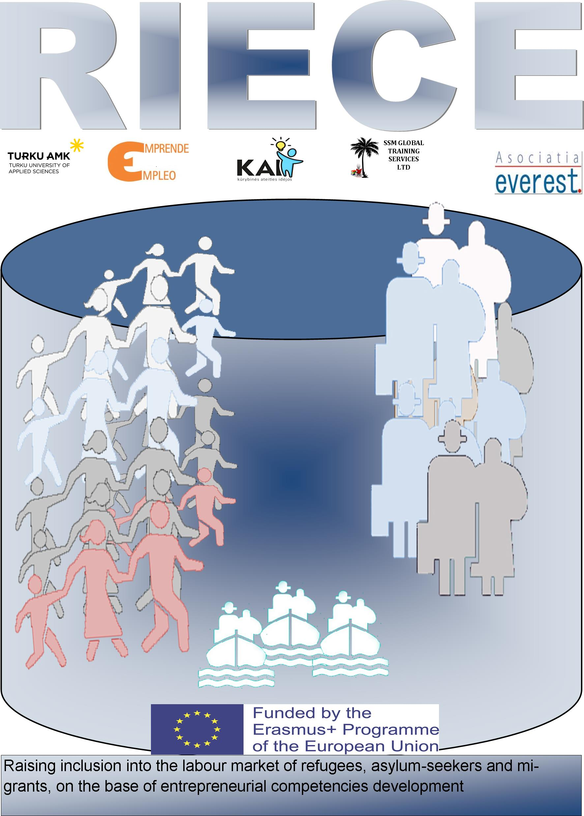

**Content**

**Target groups:**

○ Potential refugees, asylum seekers and migrants entrepreneurs

○ VET and adult education institutions

○ Jobcentres

○ Consulting companies

**Project aims:**

1. Raising inclusion into the labour market of refugees, asylum-seekers and migrants, on the base of entrepreneurial competencies development

2. Create new jobs through entrepreneurship and innovation

3. Provide disadvantaged people and unemployed to fully participate in the economy and society

4. Develop innovative training curricula, methods and contents on entrepreneurial and career planning skills to improve migrants professional training.

5. Improve the entrepreneurial and career planning skills of migrants as well as to support their integration in the EU labour market.

6. Gain knowledge from various areas experts for migrant’s social portrait conclusion.

○ Encourage refugees, asylum seekers and migrants to utilize their ideas and start-up their own businesses

Project partners will create joint Programme "Guidance for labour market integration of migrants". This Programme will consist of 5 main modules: Life Long Learning; Requirements and Needs of Labour Market; Different Situations in Labour Market; Cultural surroundings; Working culture. During the process of creating materials participants will take into consideration partners' labour markets needs and cultural differences. At the end of the project created programme will be used amongst migrants in all countries thinking about integration in the EU and career in EU international companies. Project results will be accessible in the project website, websites of the partners, as well as published in scientific journals, EPALE platform.

The expected impact of this Project: increased number of migrants with entrepreneurship and career planning competencies efficiently integrated into the EU labour market, increased competitiveness of adult training organizations. At European level the expected impact is an improvement of cooperation between different actors connected with adult educational sector in Europe. Information about project will be disseminated among different migrants’ institutions across Europe.

Launching the project Page 1

Project aims, results and   
target groups Page 1

Kick-off meeting Page 2

Coming events Page 2

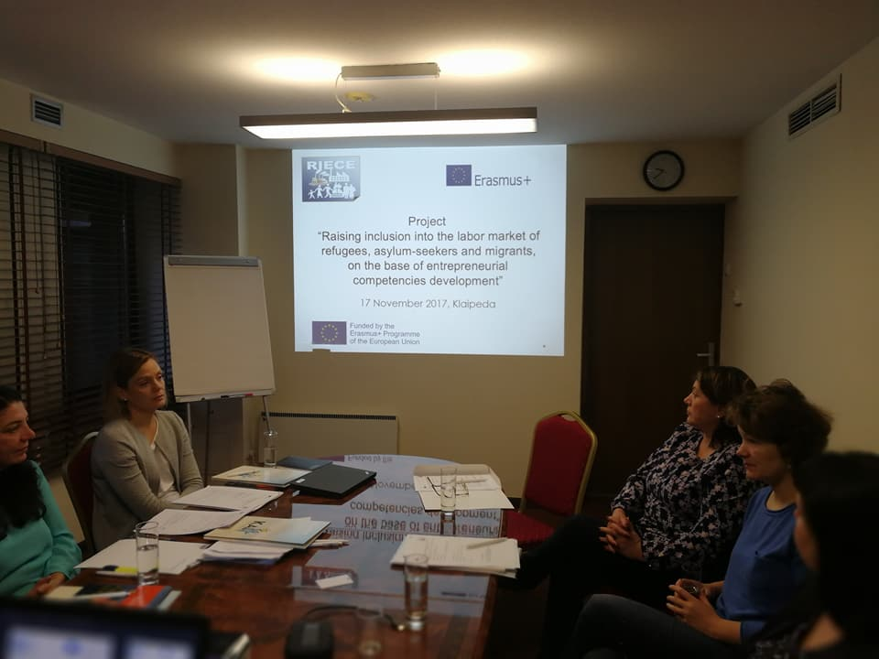

Upon ratification of the Geneva Convention, EU countries took an obligation to grant asylum to foreign nationals who were forced to leave their home countries because of war, prosecution or harsh human rights violations.

Integration of migrants in EU is very problematic. The obstacle, which results in unemployment, unqualified jobs and exploitation, is discrimination and negation of the education and qualification acquired outside the EU. Main opportunities to stimulate integration processes in EU are training and promoting of entrepreneurship. Target group of the project – refugees, asylum seekers and migrants, who are willing to be integrated into the EU labour market and/or establish own business, but experiencing lack of appropriate knowledge and skills

This objective will be achieved by comparative analysis, experience exchanges, identification and sharing of existing good practices among five organizations working with migrants’ education in Romania, Lithuania, Finland, Spain and Cyprus. All these countries are currently exposed to migrants’ integration into society.

**Launching the ”RIECE” project**

On 17th and 18th of November the Kick-off meeting for launching the “RIECE” project was held in Klaipeda, Lithuania. Partners from 5 different countries participated.

Future work in the project was planned, aims and objectives discussed. The project´s work packages were presented; timeframe was discussed and agreed on.

The consortium concentrated on planning the first activities of the project. The structure of the research was presented and discussed and tasks given to partners.

The development of the training programme for refugees, asylum seekers and migrants entrepreneurs, coordinated by NGO Creative Future Ideas, was also discussed during the meeting.

The consortium had worked on the quality management and the dissemination strategy of the project.

Number 01 January 2018 RIECE 2017-1-LT01-KA204-035194

**The consortium of the project is made of specialists in the field of education and training, research and career guidance, with relevant experience. The European co-operation will have a positive impact on the geographical areas by facilitation the dialogue and co-operation between providers of training programs for adults.**

Page 2

**Credits**

Project coordinator:   
Creative Future Ideas  
Contact: Giedrius Blazulionis  
T.: +37 69878691  
E-mail: creatfuturideas@gmail.com

Partners:  
Turku University of Applied Sciences  
Contact: Hanna Kirjavainen  
T.: +35 8403550127  
E-mail: hanna.kirjavainen@turkuamk.fi

Asociatia Everest  
Contact: Silvia Popovici  
T.:: +40 56087291  
E-mail: [asociatia.everest@gmail.com](mailto:asociatia.everest@gmail.com)

SSM Global training services LTD Contact: Stelios Georgiou  
T.: +35 724424742  
E-mail: [stelios@ssmedu.net](mailto:stelios@ssmedu.net)

Emprende Empleo European Network  
Contact: Marga Veron Jarque  
T.: +34 616906883  
E-mail: riecespain@gmail.com

**Coming events**

* Research

In order to prepare the training program for refugees, asylum seekers and migrants entrepreneurs and to ensure a successful implementation of the program in the participating countries, the project consortium will conduct a research on the main problems in integration process, competencies missing, support needed.  
The research report will be available at the end of February 2018.

* Curriculum and training program

The main aims of this activity are to design a training program for refugees, asylum seekers and migrants entrepreneurs, according to the needs and characteristics of the target group. In order to ease the implementation process, it is necessary to take into account the characteristics of the participating countries with regard to needs of labour market, working culture, expectations of employers, the needs of the potential entrepreneurs, but also the possibilities for integrating the training programme in the different adult education systems.

This project is Erasmus+ strategic partnership for adult education funded with support from the European Commission.

The content of the present material represents the exclusive responsibility of the authors and the National Agency or the European Commission will not be held responsible for the manner in which the content of the information is used.



**Kick-off meeting in Klaipeda**